**PRACTICAL 5**

**To find Literate Men and Women, Literacy Rate in Men and Women, Illiterate Men and women using total population.**

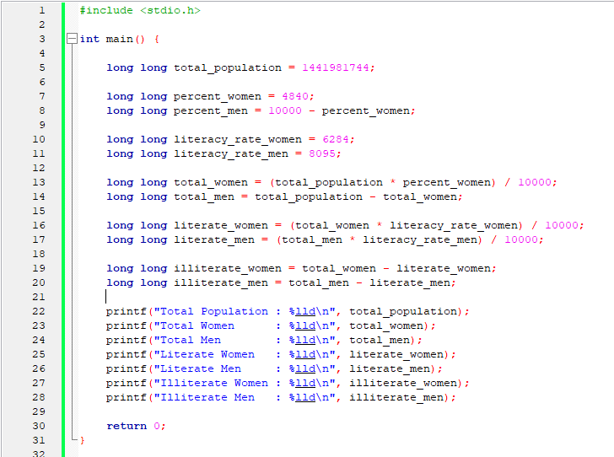

**Output:**

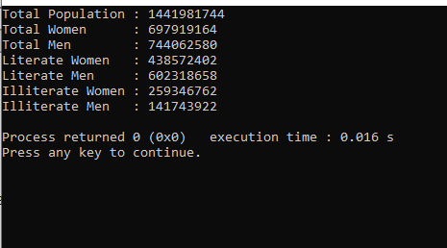

This is developed by Domadiya Rashi Jayesh

25TCEILX